**Users Guide**

1. Install Jupyter Notebook by opening up your command prompt and entering the following code:

pip install notebook

1. To run Jupyter Notebook, open your command prompt and type in the following code:

jupyter notebook

1. Download the following Jupyter Notebook file ‘Retirement Savings Interest Generator - LM.ipynb’ from Github site: [Linear-Regression/Retirement Savings Interest Generator - LM.ipynb at main · Irish-grl/Linear-Regression (github.com)](https://github.com/Irish-grl/Linear-Regression/blob/main/Retirement%20Savings%20Interest%20Generator%20-%20LM.ipynb) and press the ‘Go to File’ button.
2. Download the following dependency CSV file named ‘2022_pers_QBE.csv’ from Github site: [Linear-Regr.ession/2022 pers QBE.csv at main · Irish-grl/Linear-Regression (github.com)](https://github.com/Irish-grl/Linear-Regression/blob/main/2022%20pers%20QBE.csv) and press the ‘Go to File’ button. Note the pathway where you are saving the file, as you will need to update the file pathway in the code in cell #1 to match the file pathway of the location where you saved this file:

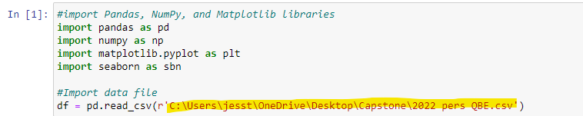

1. After setting the file pathway for the ‘2022_pers_QBE.csv’ file in cell #1 in the Retirement Savings Interest Generator – LM.ipynb file, click the ‘Run’ button for each cell in the file until you have clicked ‘Run’ for all of the cells:

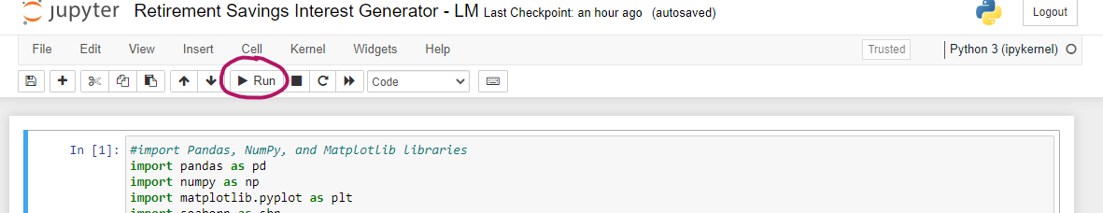

1. After clicking ‘Run’ for each cell, a new ‘Out’ cell appears below the running cell with the output:

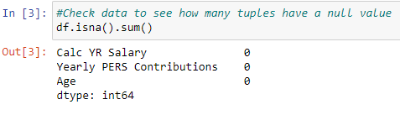

1. In the very last cell, labeled ‘In [28]’ is the user interface for you to interact with the linear regression model. When you run this cell, a new browser page will pop up in your browser using the following web page name:



1. You will be prompted to enter your age as a number. Enter your age and press ‘Submit’:

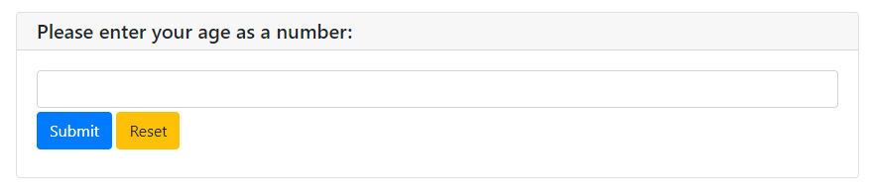

1. The next page that will populate will ask for your gross yearly salary. Please enter your salary as a number and press ‘Submit’:

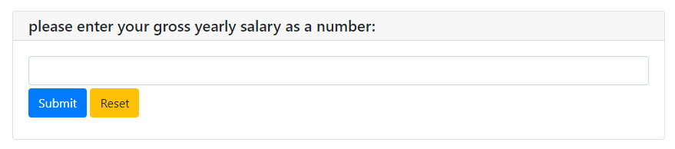

1. Finally, the amounts you entered will be passed to the linear regression model and will print out your results to the screen on the open web page:

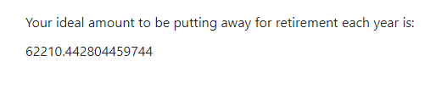

1. You can continue to enter a new ‘age’ and ‘salary’ into the web page by clicking the ‘Run’ button at the top of the Jupyter Notebook webpage, *but the previous estimate will remain at the top of the web page above the entry areas to enter your values*.

If you close out of the web application page and try to re-run the user interface cell in Jupyter Notebook, you will receive the following error message:



***To get rid of this error message, you will need to completely shut the Jupyter Notebook Retirement Savings Interest Generator – LM.ipynb program down and restart it.